# **Initiate SSH connection to the EMR Primary Node**

1) Add inbound security rule to access EMR Primary Node by clicking on EC2 security groups for the Primary node

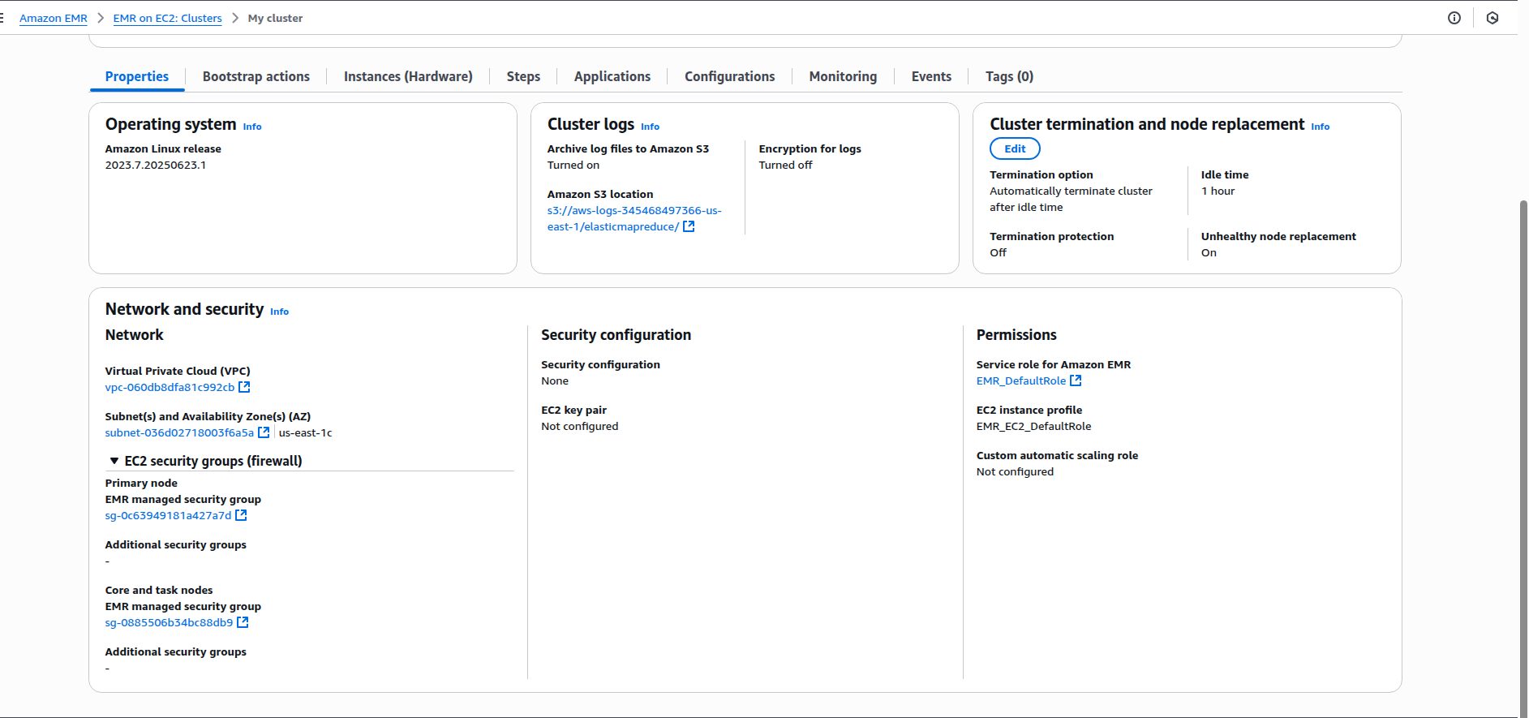

Then add inbound rule to allow all ports and all ips

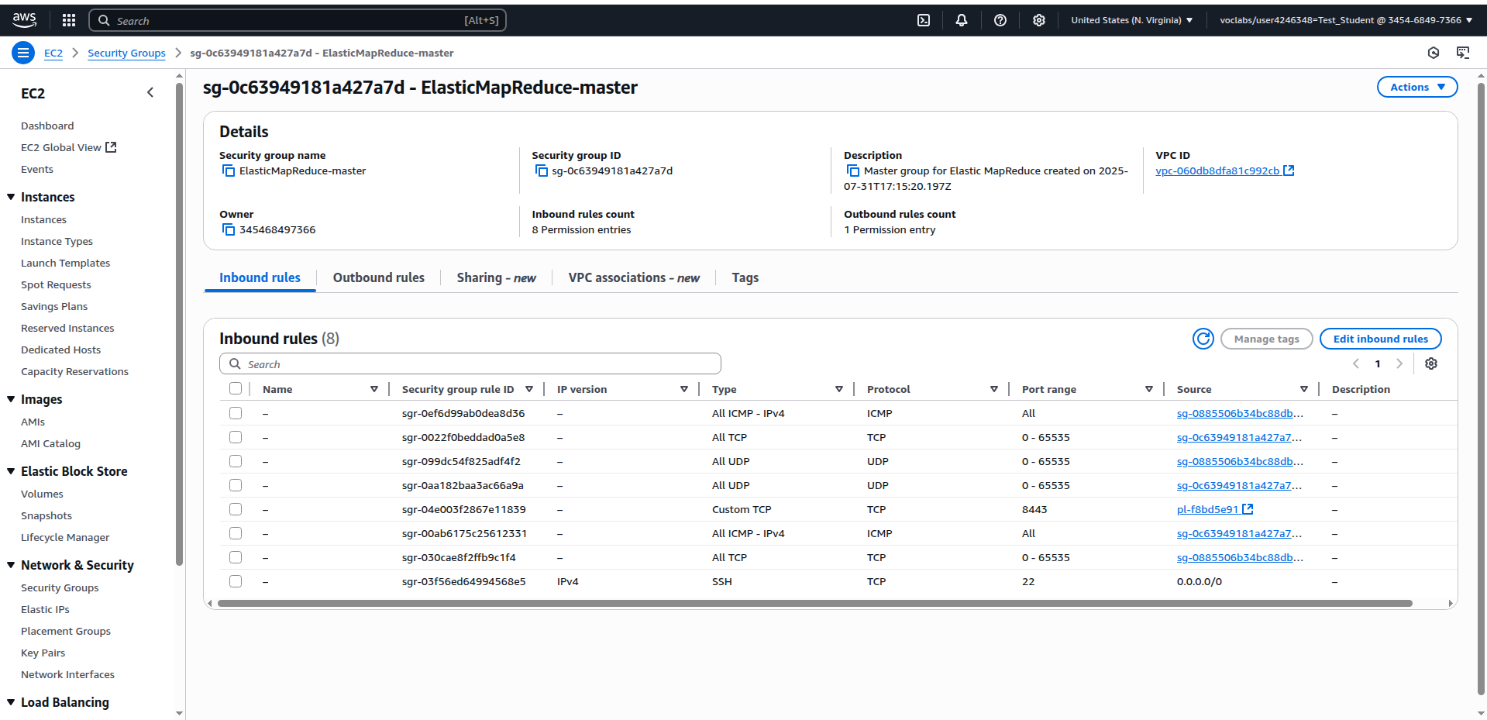

Click ok EC2 instance ID to login to the Primary Node

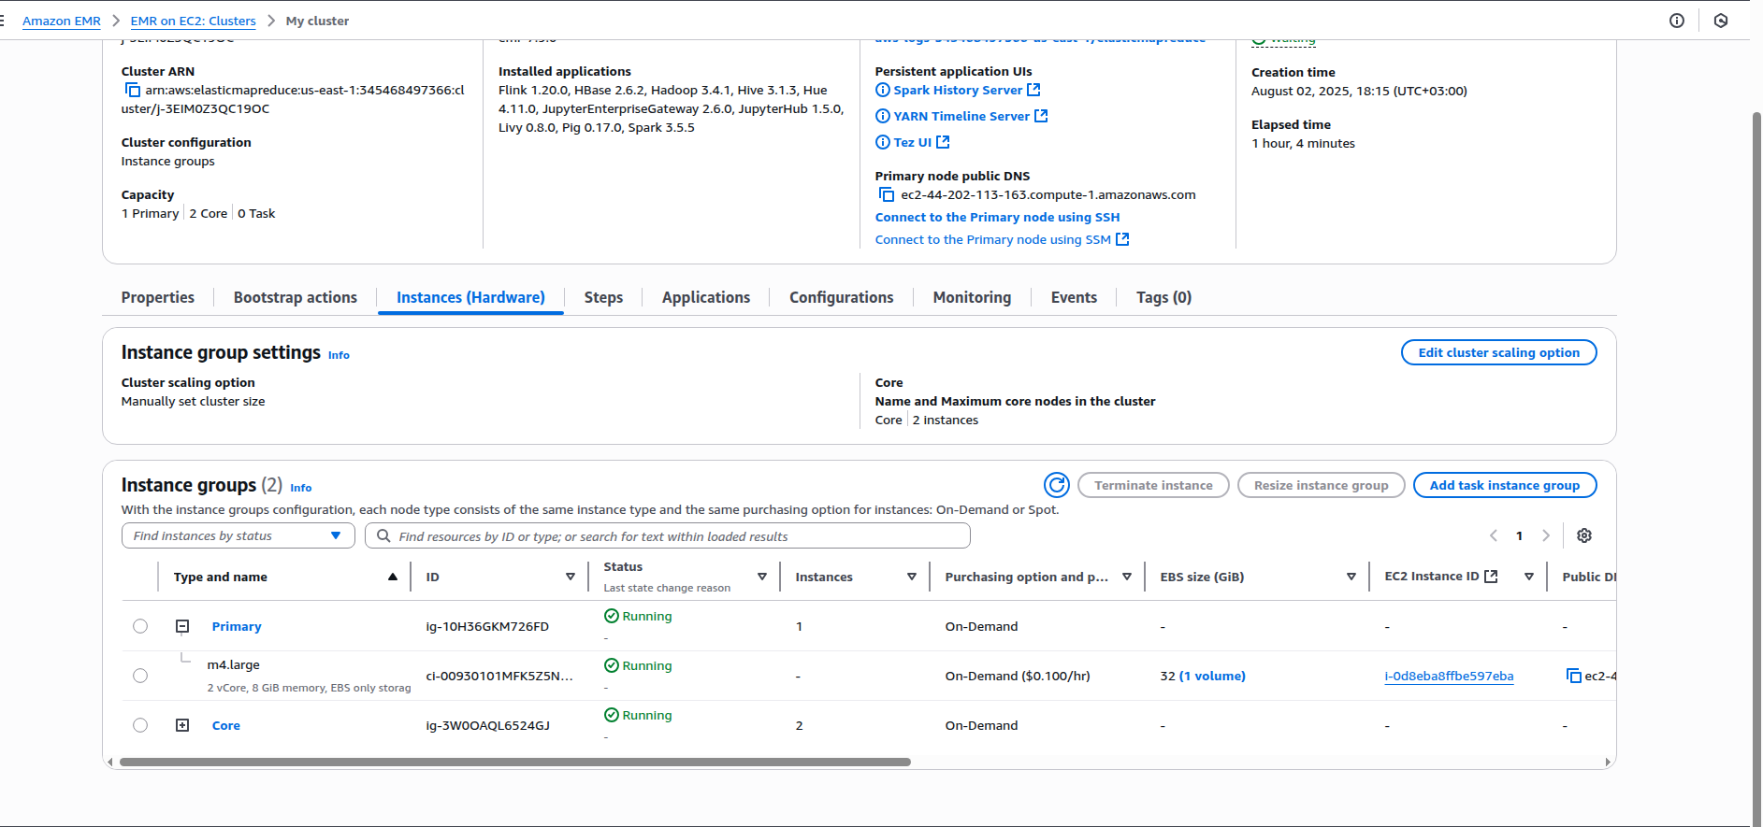

Click on the connect button

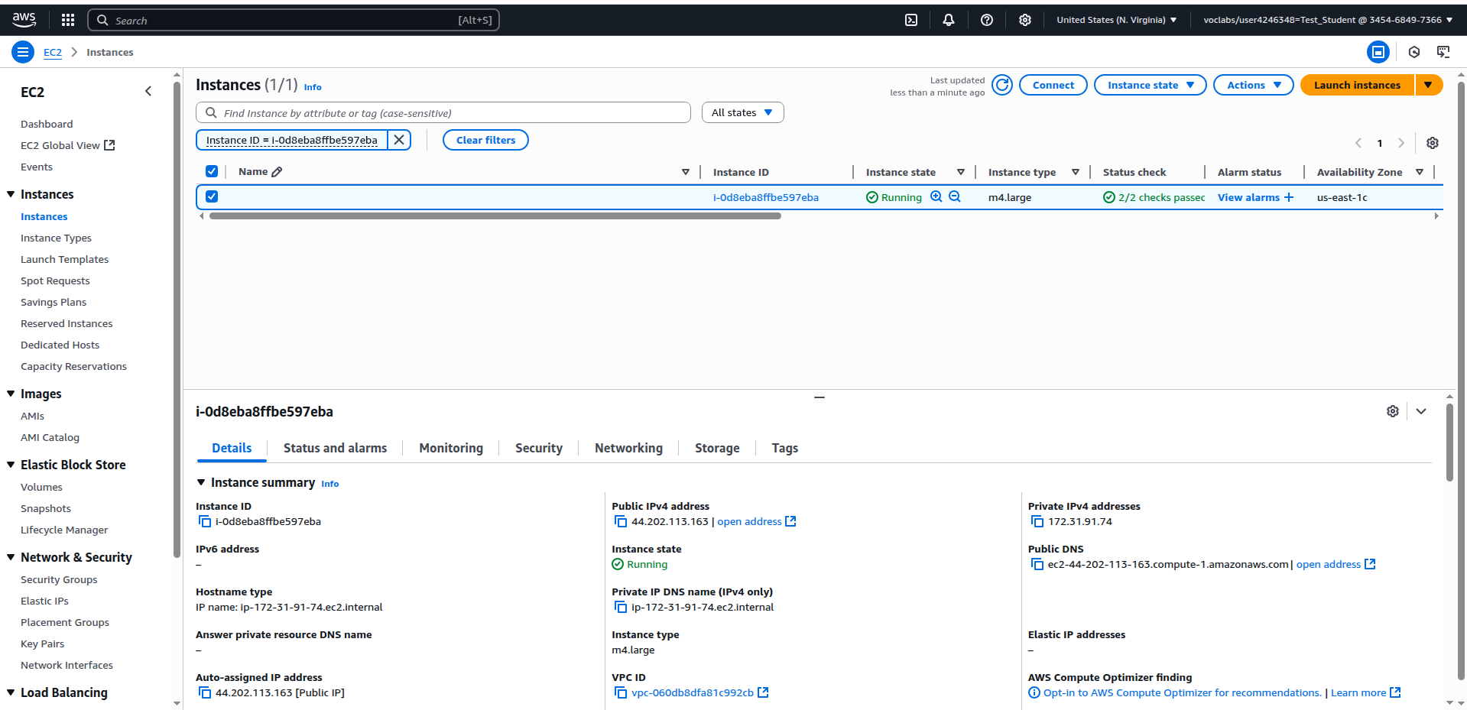

Click on the connect button

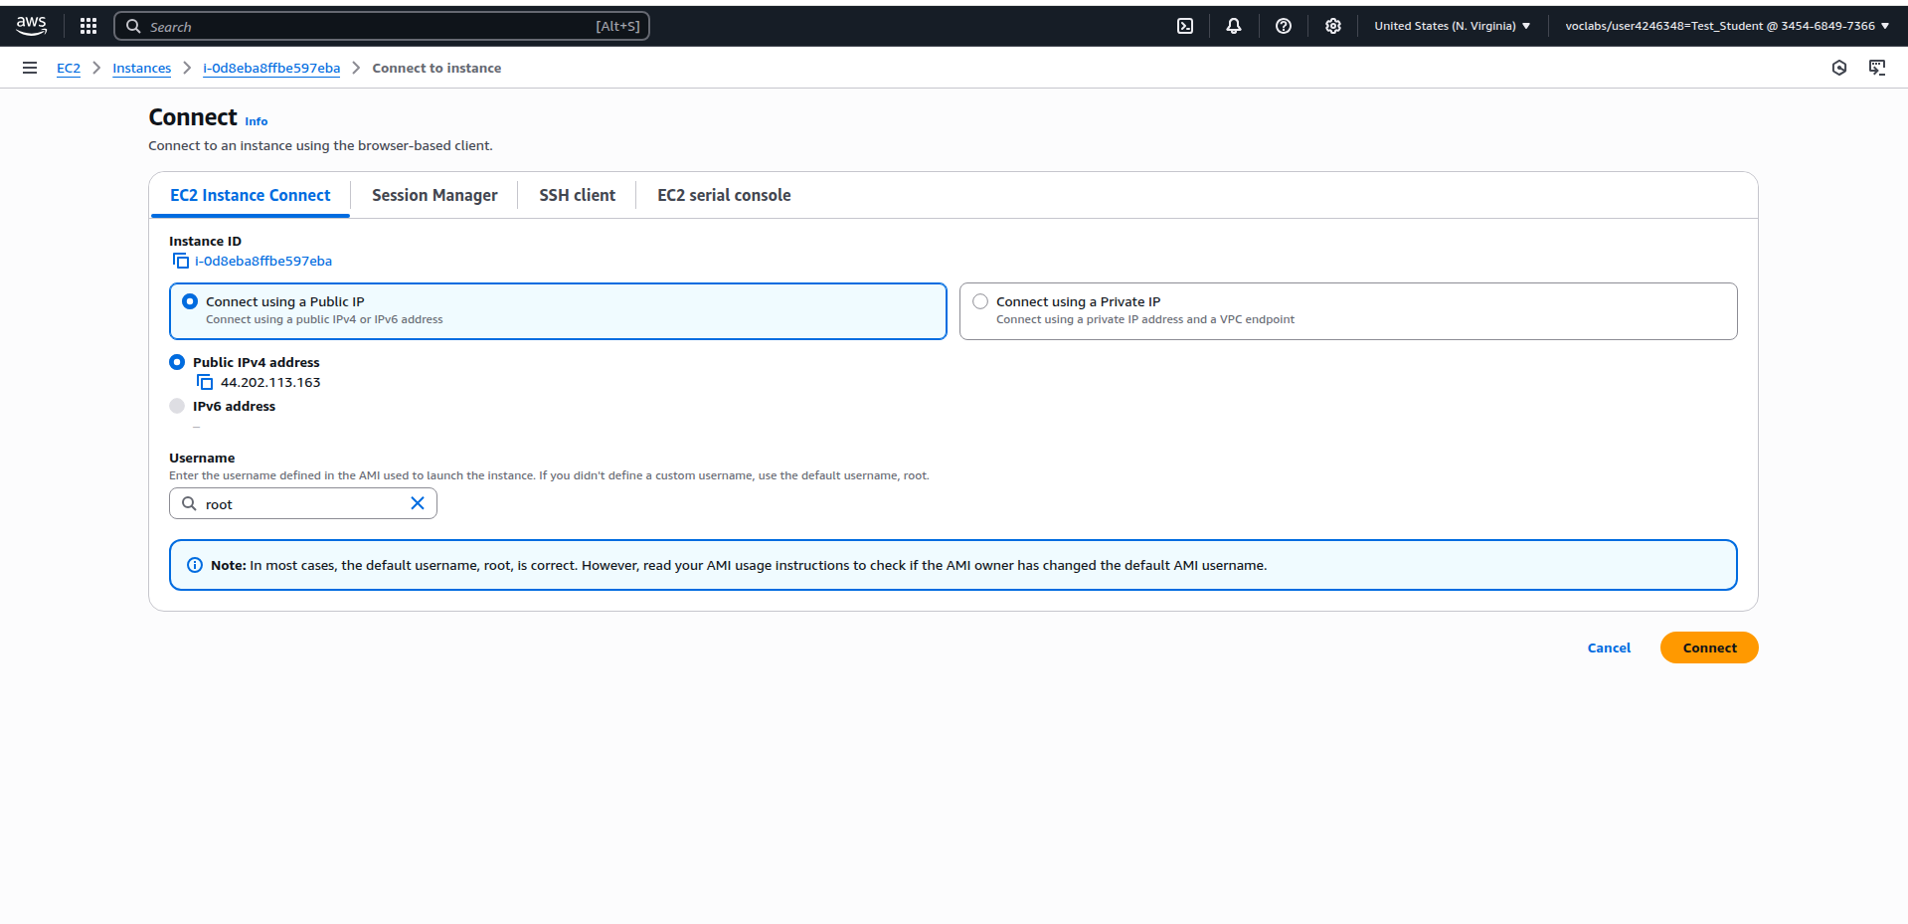

Clicking on the connect button opens an SSH command line connection:

